

Submitted By:
Umair Umar CE-25-107
Assignment:
CA Lab No. 11
Submitted To:
Mr. Mehmood
For the fulfillment of,
Circuit Analysis Lab
Department of Computer Engineering
University of Engineering and Technology, Lahore

Circuit Analysis – Lab 11
Experiment 10: Verification of Norton's Theorem
Proteus Simulation Procedure

Overview
This document describes the step-by-step procedure followed in Proteus ISIS to verify Norton's Theorem. Four separate sub-circuits were constructed on a single Proteus schematic: the original (given) circuit, the short-circuit for finding IN, the test-source method for finding RN, and the Norton equivalent circuit. A 5 V DC source was used throughout.

Proteus Schematic Overview
The figure below shows all four circuits as constructed in Proteus:
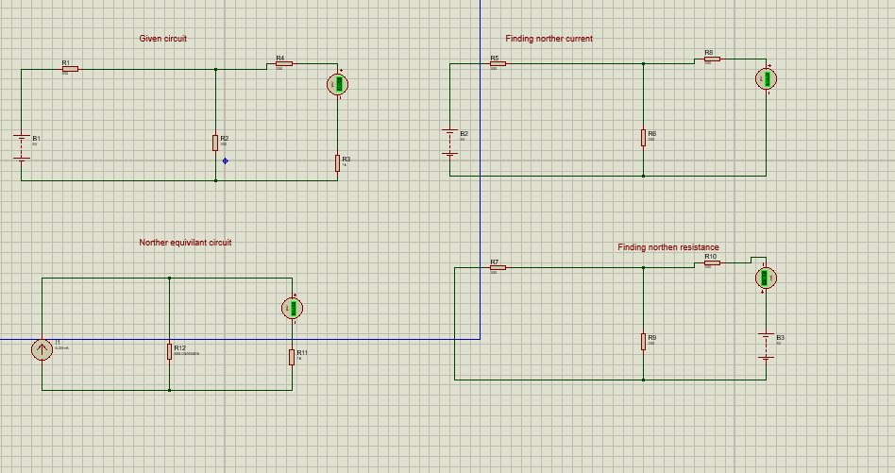
Figure 1: All four Proteus circuits for Norton's Theorem verification

Part 1 – Given Circuit (Finding Load Current IL)
The original circuit was constructed exactly as given in the lab manual using the following components:
- Open Proteus ISIS and create a new schematic.
- Press P to open the Pick Devices library. Search for and place the following components:
• Battery / DC Voltage Source (B1): set to 5 V
• R1: 330 Ω (series resistor, left branch)
• R2: 330 Ω (shunt/parallel resistor)
• R4: 330 Ω (series resistor, right branch)
• R3: 1 kΩ (load resistance RL)
• Ammeter (0–30 mA): placed in series with R3 to measure IL
- Wire the circuit: B1 positive terminal → R1 → node A. From node A: R2 goes to ground (shunt), and R4 continues to the output terminal. Connect R3 (load) and the ammeter in series from the output terminal to ground.
- Run the simulation. Note the ammeter reading — this is IL from the original circuit.
- Recorded value: IL = 1.67 mA

Part 2 – Finding Norton Current IN
To find IN, the load resistance is removed and the output terminals are short-circuited. The ammeter now directly measures the short-circuit current.
- Copy the given circuit or build a new identical circuit in a separate area of the schematic (labelled 'Finding Norton Current' in the schematic).
- Remove the load resistance R3 (1 kΩ) entirely.
- Connect a wire (short circuit) directly across the output terminals where R3 was.
- Place the ammeter in series with this short-circuit wire to measure the current flowing through it.
- Keep the source voltage at 5 V (same as before) and run the simulation.
- Recorded value: IN = 5.05 mA

Part 3 – Finding Norton Resistance RN
Since Proteus does not have a standalone ohmmeter or multimeter for direct resistance measurement, the test-source method was used: a known 5 V DC source is applied across the open terminals (with the original source deactivated) and the resulting current is measured. RN = Vtest / Itest.
- Build a third circuit in a separate area (labelled 'Finding Norton Resistance').
- Replace the original voltage source B1 with a short circuit (a plain wire) — this deactivates the independent source.
- Remove the load resistance from the output terminals (leave them open).
- Connect a new 5 V DC test source (B3) across the open output terminals.
- Place an ammeter in series with B3 to measure the test current Itest flowing into the terminals.
- Run the simulation and note the ammeter reading.
- Calculate RN using Ohm's Law:
RN = Vtest / Itest = 5 V / Itest
- Recorded value: RN = 495.05 Ω

Part 4 – Norton Equivalent Circuit
The Norton equivalent circuit was constructed using the values of IN and RN obtained from Parts 2 and 3 above.
- Build the equivalent circuit in a fourth area (labelled 'Norton Equivalent Circuit').
- Press P and search for IDC (DC current source). Place it in the schematic.
- Double-click the current source and set its value to 5.05 mA (the IN measured in Part 2).
- Connect RN = 495.05 Ω (resistor R12) in parallel with the current source — one end of R12 to the positive terminal of the current source, the other end to the negative terminal.
- Connect the load resistance RL = 1 kΩ (resistor R11) in parallel with RN and the current source.
- Place an ammeter in series with RL to measure the load current IL from the equivalent circuit.
- Run the simulation and note the ammeter reading.
- Recorded value: IL (equivalent circuit) = 1.67 mA

Result and Verification
The load current measured from the original circuit (Circuit I) and the Norton equivalent circuit were compared:

E (V) | IN (mA) | RN (Ω) | IL (mA) — Both circuits
5 | 5.05 | 495.05 | 1.67

Since the load current IL = 1.67 mA was the same in both the original circuit and the Norton equivalent circuit, Norton's Theorem is successfully verified.

